Home Where AntLive At? Media Upcoming Projects

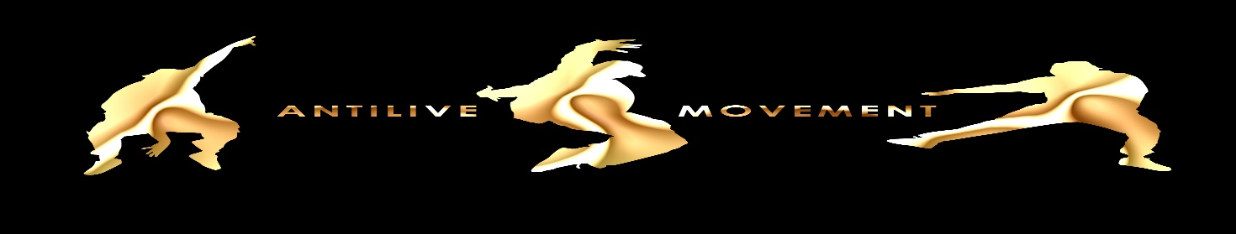

**BACKGROUND PICTURE**: DETROIT City NIGHT LIFE

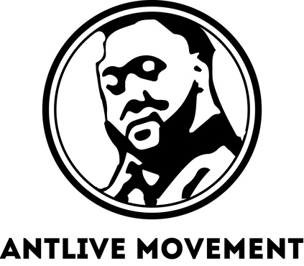 Snap chat social media

Facebook social media Tres Leches

INSTAGRAM SOCIAL MEDIA

DJ OF THE MONTH OR WEEK

SOUNDCLOUD AUDIO

Video’s playing, like 3 different ones playing in rotation (Old videos)

New Videos then after time it goes into the rotation videos from either the left or right side.

Video’s playing, like 3 different ones playing in rotation (Old Videos)